The overall objective of this project was to determine a way for Big Mountain Resort to recoup the extra operational costs for the new chair lift and to maintain a profit margin of 9.2%. One way this can be achieved is to evaluate the price of adult chair lift tickets on the weekend and this is what I have concluded.

In the cluster graphs below you will see all of the ski resorts have been clustered into one of three groups. In figure 1 below you can see how Big Mountain compares to all other ski resorts in regards to summit elevation and vertical drop. Big Mountain is represented by the black dot.

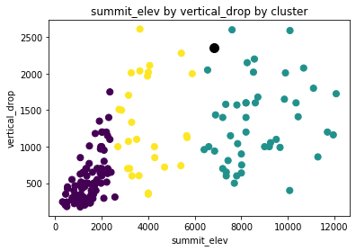

Figure 1

Now let us focus in on the price of an adult chair lift ticket on the weekend. The current price for an adult weekend chair lift ticket is $81. I recommend increasing the price to at least $82.39 in order to recoup the extra operating costs and I will now address some concerns you may have. If we increase the price of the adult weekend chair lift ticket will that push customers to other ski resorts? Figure 2 shows us there are other resorts charging higher prices with a lower vertical drop. Figure 3 shows us, for the most part, if a resort is open longer then they charge more per ticket. Lastly, figure 4 shows us Big Mountain’s vast amount of skiable terrain available to customers compared to other resorts.

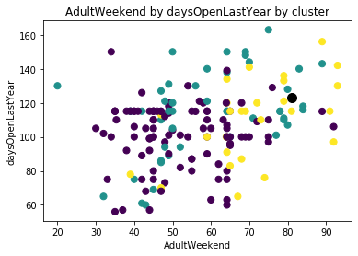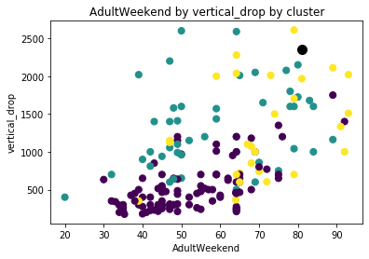

Figure 2 Figure 3

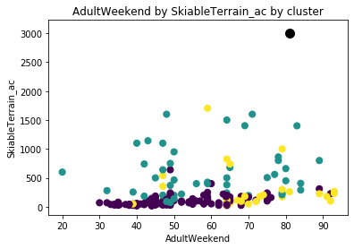

Figure 4

All of these points we have concluded from figures 2 – 4 allow us to confidently see that if we were to increase the price to at least $82.39, then Big Mountain would not need to worry about customers leaving to go to other resorts because of what Big Mountain has to offer compared to the other resorts.